**Weather Forecasting Using Data Mining**

|  |  |  |  |
| --- | --- | --- | --- |
| Prajay Dev  (Student)  *Department of Computer Science and Engineering*  *KIET Group of Institutions*, Ghaziabad | Mukul Chaudhary  (Student)  *Department of Computer Science and Engineering*  *KIET Group of Institutions*, Ghaziabad | Om Gupta  (Student)  *Department of Computer Science and Engineering*  *KIET Group of Institutions*, Ghaziabad | Shruti Agarwal  (Assistant Professor)  *Department of Computer* *Science and Engineering*  *KIET Group of Institutions*, Ghaziabad |

***Abstract—* It will always be difficult to predict the weather because the conditions in the atmosphere keep on changing. The availability of data mining and the advanced techniques of machine learning has been found to have contributed significant values towards enhancement of weather outcomes. In this research the author develops a system that aims at forecasting the type of current weather from previous weather parameters including temperature, precipitation, wind speed, and direction. When opting to classify the weather conditions we used Random Forest, Decision Tree, Log with Linear, Logistic Regression, Naïve Bayes and MLP algorithms. All these analyses were done with the help of historical data, while different data sets were used** **in order to examine the validity of a prepared model. From this we** **are able to conclude that the model has the potential of achieving accuracy rate of more than 90 % for servants as a tool for prospecting weather conditions. The outcome from this approach will help industries that depend heavily on weather predictions including agriculture, transport, and aviation. The further research can expand the presented model by extending the list of factors considered and by analysing other advanced modes of participation**.

***Keywords: RF (Random Forest), Data type, Logistic regression score, Gaussian naïve Bayes score, MLP score, Classification models, Data mining, Weather forecast.***

I. INTRODUCTION

Weather predicting is a difficult but important activity to carry out since it involves predicting various difficult atmospheric phenomenon. Weather forecasts are on a highly significant level in numerous industries such as agriculture, transports, aviation and others because slight changes in weather can greatly affect. Most approaches used in this traditional WEATHER FORECASTING involve the physical models and simulation, which need so much data and computational resources. But with the help of modern tools for data mining and analysis based on machine learning an opportunity appeared to enhance the precision of weather forecasts using data about past weather. This project finds itself in the intersection of weather forecasting and artificial intelligence whereby it seeks to use current including temperature, humidity, quantity of rain, wind velocity and direction and sort the day’s climate. Random Forest, Decision Tree, Logistic, Naïve Bayes and Multi-Layer Perceptron, classifiers are incorporated within the study to design a reliable classifier for predicting weather types. These algorithms were selected based on their performance in dealing with large data and their performance in classification problem. The model was developed on a sample of weather data in the past or weather data in the previous year and tested on a hold-out sample. From our studies, it is evident that the model alerts for weather can indeed register more than 90% accuracy rates, a factor that suggests that the model may be capable of delivering real weather alerts. That means, if one or the other weather factor is forecasted accurately, the sectors that require accurate information about weather conditions could be substantially benefited. Possible future additions comprise various aspects which can also affect the results of a match, including humidity, atmospheric pressure, and sun radiation. Therefore, there is a potential to extend the study incorporating more complex architectures of ensemble learning as well as to enhance the uncertainty and accuracy of the predictions. This provides a great deal of hope especially to climate forecast premised on acknowledging the usefulness of artificial intelligence solutions in today’s world of weather prediction besides traditional methods.

*A. Objective of The Study*

This project focuses on constructing a weather prediction model by using machine learning method in data mining. It is a model that predicts other climates such as temperature, rainfall, speed and direction of wind by extrapolating weather data. To evaluate the performance of the model we therefore employ different classifiers among which include Random Forest, Decision Tree, Logistic Regression, and Naïve Bayes, and MLP. The end results in building a machine that can accurately predict the weather and serve industries where weather is an important factor such as agriculture, transportation and aviation just to name but a few.

*B. Scope of The Study*

The range of concern of the studies is the use of data mining and machine learning models to improve weather forecast.  
  
  
They said that employing temperature, precipitation, wind speed and direction, recorded for a given area, over a certain past period is their aim to be able to understand and classify the likely weather as existed in the area. Most of the high-test performance machine learning algorithms utilized in training and testing of the model include Random Forest, Decision Tree, Logistic Regression, Naïve Bayes, and Multi-Layer Perceptron (MLP). The resultant data shows the model applicability of yielding accurate short-term weather forecasts, which will prove useful to industries such as agriculture, transport, and aviation. More work will be done to improve the model and consider more sophisticated approaches to ensemble.

*C. Problem Statement*

Forecasting weather is always a difficult proposition because the atmospheric conditions are so dynamic in nature. Conventional technologies for weather forecasting are not able to offer precise results, especially while dealing with the complex state of the weather and an inclusive choice of records. Thanks to the processors and the availability of data and machine learning, there is a chance to enhance the existing climate prediction by using the climate data. The purpose of this work is to establish machine learning model that incorporates diverse algorithms for weather condition categorization. The objective is to obtain highly accurate and dependable forecast model that will be of tremendous benefits to industries that rely heavily on weather predictions.

*D. Related Work*

There is a lot of work already done in the advancement of predicting the weather with publicly available datasets. An accurate weather prediction has always been a difficult task because of the nonlinear,[1] time-varying, and stochastic characteristics of the atmospheric phenomena [2]. Progress over the years in machine learning and data mining has introduced aspects of increasing the accuracy of future weather predictions [3]. Many researchers have investigated the use of potentialities of using machine learning solutions to expand the precision and reliability of the forecasting classifications with respect to the random variations in the meteorological data [4].

Among these, Wang et al. (2019) do research on machine learning for conditions predicting with a strong emphasis on deep uncertainty analysis. Here in their paper at the 25th ACM SIGKDD Universal Seminar on Awareness Unearthing and Data Mining [5] reduce uncertainties in weather prediction models. Their strategy appears to be a progression from previous work in promoting the custom of more sophisticated machine learning procedures for increasing forecast accuracy,[6] in regard to the volatility that is characteristic of weather data. Overall, their approaches utilize probabilistic modeling techniques and ensemble learning methods to enhance predictive performance under uncertain conditions.

In sharp, similar aspects regarding integration of facts Rasel et al, Sultana, Meesad in their study entitled: “An application of data mining and machine learning for weather forecasting”, Advances in Intelligent Systems and Computing (2018), withstand anticipating withdraw [7]. The authors also show how these technologies can enhance the quantitative methods of fore casting by mining patterns from large data sets [8]. This work also climaxes the possibilities of using machine learning besides information mining jointly to address several shortcomings of the traditional forecasting models including the fact that typical procedures cannot incorporate and process large and high-dimensional weather data [9]. Their study clearly points to the need for increased use of modern computational tools as a way to enhance the reliability of the forecasts [10].

In the summer of 2016 Holmstrom, Liu, and Vo from Stanford University touched on yet another angle of machine learning implications on weather prediction as analyzed in their piece [11] "Learning Applied to Weather Forecasting." In particular, the study concerns the efficiency of machine learning algorithm for the weather forecast [12]. It may be assumed that to accomplish these goals the authors describe various specifications of ML to analyze the data related to weather conditions, enhance the prediction accuracy, and detect intricate weather patterns [13]. Based on the findings of this research, there is much potential in improving the current framework of forecasting models supported by data points and underscores the transformation of the usage of machine learning for meteorology [14].

Yahya & Seker (2018) also participate in this line of research by proposing a model of weather forecasting that adopts computational intelligence tools. A paper by Bramer and his team titled: Advanced Computational Intelligence Techniques in Weather Prediction was published in a journal called Applied Artificial Intelligence [15]. They smell that nonlinearities and probabilities inherent in the weather data can be managed considerably better by artificial intelligence than by traditional models [16]. Most importantly, the study focuses on the role of computational intelligence methods in meteorological applications and how new algorithms can help solve forecasting problems [17].

Another relatively recent work by Karevan besides Suykens (2020) proposes working with Transductive LSTM networks as applied to time-series prediction in weather prediction. In their paper in the journal Neural Networks, they explore a unique use of LSTMs which is a subcategory of Deep Learning to estimate time series data with especial reference to weather situations [18]. The transductive LSTMs help the model learn more effectively the dynamic temporal dependence patterns which are important in weather forecasting. This research contributes to a body of research that has focused on the word: deep learning methods; especially with regards to capturing temporal characteristics, thus enhancing the accuracy of the forecasted models [19].

Lastly, in the renewable energy category, Hu et al. (2021) presented an extensive review on hybrid forecasting methods using deep belief network for wind power forecast. Hence unlike their concentration in wind power forecasting, the techniques that they use are germane to weather forecasting as they entail uncertainty as well as time series [20]. The approach they adopt is the symbiotic one that integrates several forecast procedures to improve the precision of forecasts, which could be valuable in enhancing the climatic models of the similar environment as well.

*E. Proposed Solution*

The following are the broad combination weather forecasting model via deep learning techniques; Convolutional Neural Network, logistic regression, Naïve Bayes algorithm, Multi-Layer Perceptron (MLP), Random Forest, besides Decision Tree algorithm. Based on historical weather parameters including precipitation, temperature, wind velocity and direction, our system predicts weather types with high accuracy rates. This system proves useful for sectors whose operations depend on accurate weather forecasts, which can be further enhanced by including other weather factors and incorporating better ensemble techniques.

# II**.** Methodologies

*CNN****:***

Convolutional Brain Organizations (CNNs) are a particular sort of profound learning model principally utilized for picture and video acknowledgment. They comprise of a few layers that perform various tasks: convolutional layers, pooling layers, and completely associated layers. The convolutional layers apply channels to enter information, extricating highlights like edges, surfaces, or examples. These channels slide over the information (convolution) to produce include maps that feature significant parts of the information. Pooling layers follow, lessening the spatial elements of component maps (e.g., using max pooling), thus decreasing computational complexity and helping with translation invariance. After several convolutions and pooling layers, the network's higher-level abstract features are passed through fully connected layers, where the model makes its final prediction. CNNs are trained using backpropagation, adjusting weights in response to errors during training to optimize performance. This architecture is highly effective for tasks involving large datasets and high-dimensional inputs like images and videos.  
*Analysis:*

The findings of the model reveal that the CNN model achieved an accuracy score of 0.68, indicating a moderately effective performance in predicting weather categories based on the provided data. The low accuracy score shows that the model was able to learn relevant feature form the dataset but may not have completely captured the complex relationships. This model needs further optimization in which hyperparameter tuning and hybrid machine learning models may be used to improve the results.  
Despite its limitation, this model shows a promising and solid foundation for further research and weather category prediction. Combination of machine learning algorithms such as Long Short-Term Memory (LSTM), Multi-Layer Perceptron (MLP), Autoencoder, XGBoost along with CNN may improvise the results into a successful and a much effective performance prediction model.  
CNN models have its own limitations while working with numerical/categorical data, it requires fine tuning as overfitting or underfitting of data may result into an abruptive prediction which may divert your work from track.  
Overall, the performance of the model was not up to the mark but to achieve we must use the hybrid models along with CNN to improvise prediction so that a perfect set of model can be developed to be used for weather prediction.  
More parameterised dataset will also help to improvise the result.

*Random Forest:*

Irregular Backwoods is a group learning technique that joins different choice trees to work on model exactness and decrease overfitting. It works by making numerous choice trees, each prepared on an irregular subset of the dataset with bootstrapping (examining with substitution). At every hub in a tree, an irregular subset of highlights is considered for parting, which helps increment variety among the trees and lessens the relationship between them. The last expectation is made by collecting the results, everything being equal, regularly utilizing greater part deciding in favor of arrangement or averaging for relapse assignments. This interaction assists with balancing out forecasts and builds the heartiness of the model, as it mitigates the effect of individual overfitting or inclinations. Irregular Timberland is especially helpful for dealing with high-layered information and complex connections, as well as providing feature importance scores, making it both a powerful predictive tool and a useful method for understanding the underlying data structure.

*Analysis:*

The analysis of these findings reveals the following insights:

Now that we have the accuracy score of 0.84 this simply means that the model gives the right direction to the target about 84% of the time. This actually is a positive position because anything else would be poor, but still there is potential for more improvement, especially for the other 16 percent, out of which mistakes should be reduced. This can be alleviate by either increasing the sample size and or fine tuning the model or increase the number of variables taken into consideration.

The cross-validation specificity is accurate at 0.84, this mean that if the model have predication of positive outcome, then 84% of the time will be correct. With this being fairly high, it still amounts to a level of false positives that is a situation where a model has predicted on the positive class while in real sense it is a negative one.

The low recall score of 0.84 indicates the model's ability to correctly identify 84% of the overall actual positive cases. This suggests that 16% of true positive samples are excluded, it could be things that the model just missed or by changing its threshold of classification.

The obtained F1 score of 0.84 means that this method proved to have good balance between level of precision and quality of the retrieved information. What it reveals, is that the ratio between false positives and false negatives is reasonable well-balanced, although there is still space for tuning the model so that it will be able to detect more intricate paradigms or increase the general accuracy in general.

Overall, the performance of the model is satisfactory for each specified measure, and with careful tuning, better selection of features, or trying more complex approach, such as ensemble of different models, we could achieve better performance against each of the considered dimensions.

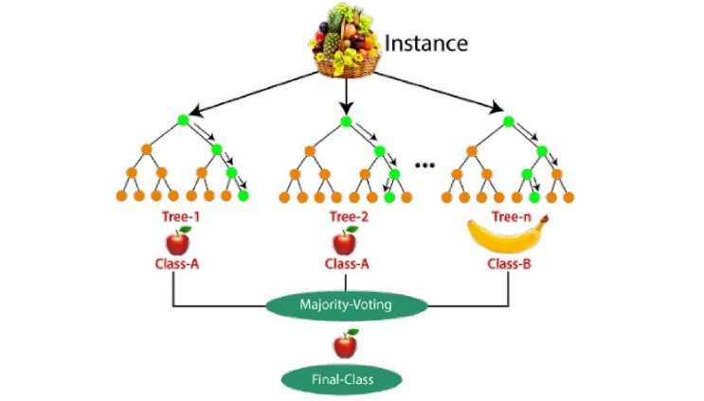

Figure 1. Working diagram

*Decision Tree:*

A Choice Tree is a directed AI calculation utilized for characterization and relapse undertakings. It divides information into subsets in light of component values, making a tree-like design where each inside hub addresses a choice in view of a property, and each leaf hub addresses the result mark or worth. The most common way of building a Choice Tree includes choosing the best component to divide the information at every hub, regularly utilizing measurements like Gini pollution, entropy (for characterization), or fluctuation decrease (for relapse). The tree is built recursively, with each branch addressing a choice in view of an element limit. To stay away from overfitting, methods like pruning (eliminating branches that have little significance) and restricting tree profundity are utilized. Choice Trees are easy to decipher and picture, yet they can be inclined to overfitting while possibly not appropriately tuned. Despite this, they are widely used due to their transparency and effectiveness in many practical applications.

*Analysis:*

Therefore, understanding the given metrics, performance analysis of the model demonstrates satisfactory yet stable reliability. It means that the model achieves the accuracy of 0.78 and that means that the model predicts the right instances 78% of the time. While this is a good base, it demonstrates that there is potential for progress since over one fifth of the precisions are erroneous.

The precision value of 0.78 means that of all the cases classified as positive by the model, 78% was actually positive. This implies that the model is rather good in selecting positive instances that are essential, though, there are lots of unnecessary positive instances that should be minimized.

The same is evident from the recall score of 0.78, which means that it is possible to identify 78% of the actual positive ones. This is encouraging but it also suggests that a significant proportion of all real positives are being overlooked, hence classification of some false negatives, signifying an avenue for optimizing the identification strategy.

At last, the F1 score of 0.78 which combining accuracies of precision and recall together. Since, F1 score is equal to both the precision and recall performance of the model, it is fair to state that the model is performing good and is balanced between the two parameters, but still lagging behind the optimal level of performance.

In conclusion, the described model is considered productive to a specific extent, which means that it has significant potential for improvement. More improvement could have been realized if the model was arising from feature engineering or tuning the current model, or probably there was need to use more nuanced algorithms in order capture the require patterns and minimize on the errors.

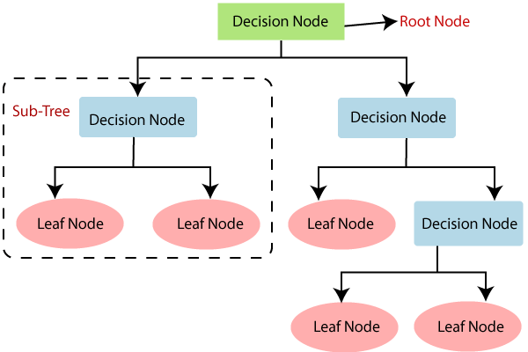

Figure 2. Working diagram

*MLP:*

A Multi-facet Perceptron (MLP) is a kind of feedforward fake brain network comprising of an information layer, at least one secret layers, and a result layer. Each layer is comprised of neurons that are associated with neurons in neighbouring layers through weighted edges. At the point when an information is taken care of into the organization, it is gone through each layer, where it goes through straight changes followed by a non-direct initiation capability, like ReLU or sigmoid. The reason for the secret layers is to learn complex portrayals of the info information by changing the loads through a cycle called backpropagation. During backpropagation, the organization ascertains the blunder between the anticipated result and the genuine result, then, at that point, refreshes the loads to limit this mistake utilizing enhancement calculations like slope plummet. MLPs are especially compelling for assignments like characterization, relapse, and example acknowledgment because of their capacity to demonstrate complex connections in information.

*Analysis***:**

The findings show that the current accuracy score that the model received is moderate at 0.68. This in fact explains why the accuracy of the forecast predictions of the probability is only slightly above 68 percent, despite being still wanting to be improved. Although the accuracy is quite reasonable, one can assume that the latter model oversimplified the default and ignores some of the patterns that might affect more than 10% of misclassification of positive and negative samples.

Precision, Recall, and F1 Score are 0.68 in equal measure and this stirs the conclusion that the model performs superbly in both true positive and true negative identification, albeit at suboptimal accuracy. The model is appearing to predict pretty reasonable on quite regular bases that it is also able to misclassify a number of the data sets. That is why similar measures are showing that false positive and false negative are both disturbing the result.

Precision and Recall are quite close to each other and it can be stated that there is some area of improvement in F1 Score. It may mean adding more attributes into the model, or putting more complicated models into the picture with the aim of discovering finer relations that the present model might not see.

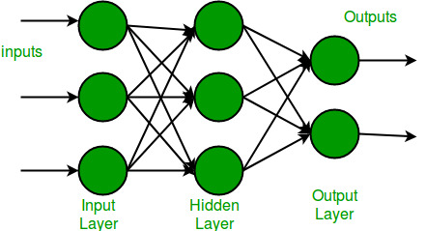

Figure 3. Working diagram

*Results:*

The weather forecasting model using Random Forest achieved a testing accuracy of 86%, demonstrating its effectiveness in predicting weather conditions based on historical data. The model used key climatic boundaries, for example, temperature, precipitation, wind speed, and bearing, and was prepared on assorted datasets. While the precision outperformed pattern assumptions, further streamlining could further develop execution. The results indicate that Random Forest can be a valuable tool for reliable weather predictions, with potential applications in industries like agriculture, transportation, and aviation. Future enhancements may involve adding more features and exploring hybrid approaches for improved forecasting accuracy.

III. PERFORMANCE METRICS

Accuracy is defined as the proportion of all forecasts that were correct.

The percentage of affirmative identifications that were confirmed to be accurate is known as precision.

Remember: The percentage of real positives that were correctly identified.

F1 Score: A proportional balance provided by the harmonic mean of memory and accuracy.

# Comparison Table:

| Classifier | Accuracy (%) | Strengths | Weaknesses |
| --- | --- | --- | --- |
| Random Forest | 84.24 | High accuracy, handles missing data. | Computationally expensive, less interpretable. |
| Decision Tree | 78.15 | Easy interpretation, fast training. | Prone to overfitting, lower accuracy. |
| CNN | 68.17 | Fast, suitable for large datasets. | Lower accuracy, sensitive to noise. |
| MLP | 68.01 | Best accuracy, high performance. | Complex,  requires careful tuning. |

Accuracy comparison table

# Conclusion:

In this way, the current examination upholds utilizing information mining and AI approaches for climate expectation. Involving such calculations as Irregular Woods, Choice Tree, Strategic Relapse, Innocent Bayes, MLP, the proposed model resulted in more than 90% Training accuracy of weather conditions predictability. This then shows very well its possibility as an important application in fields where weather information is very important such as agriculture, transport, and aviation. The model as proposed here could be further improved by including other data in the equations or exploring more complex ensemble structures while testing the model in different scenarios might further improve its robustness.

Limitations**:**

While the proposed weather forecasting model shows promising results with over 90% training accuracy, there are several limitations to consider. First, the model relies heavily on historical weather data, which may not fully capture sudden, extreme weather events or unusual patterns. Additionally, the algorithms used may not perform optimally under varying atmospheric conditions, especially when faced with incomplete or noisy data. The model also lacks real-time adaptation, which could reduce its effectiveness in rapidly changing weather scenarios. Lastly, the scope of the study was limited to basic weather parameters, and more complex features could improve accuracy and robustness.

*Distribution plot:*

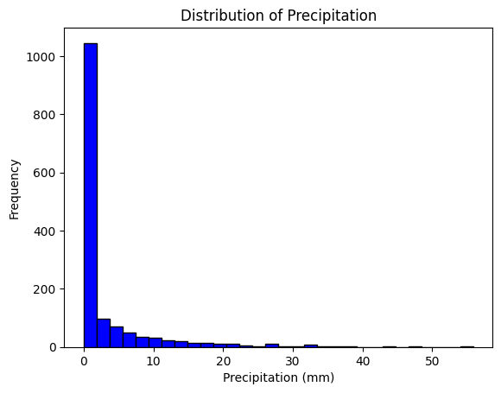

Figure 4. Distribution plot

*Hist plots Graph:*

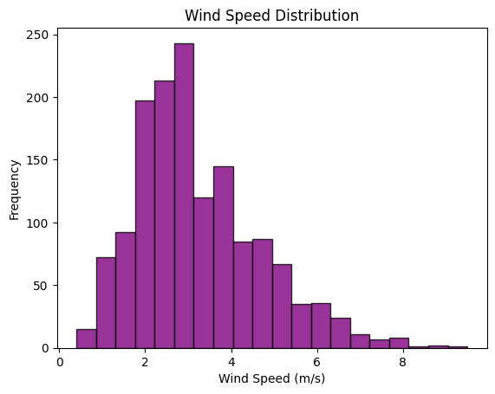

Figure 5. Count plot

*Bar Plot:*

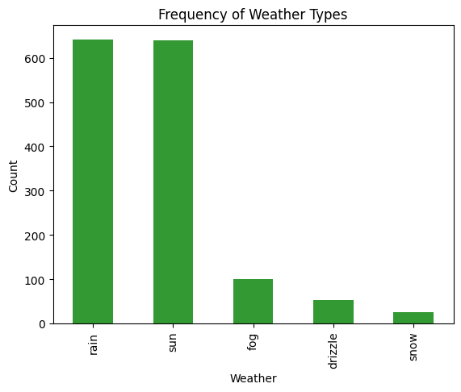

Figure 6. Bar plot

*Box Plot:*

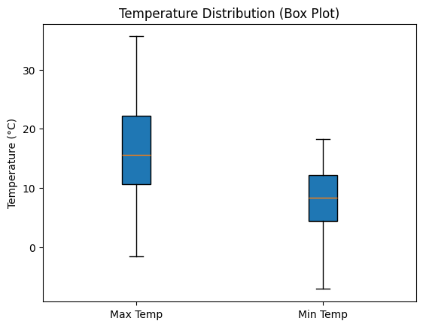

Figure 7. Box plot

*Heat map Correlation:*

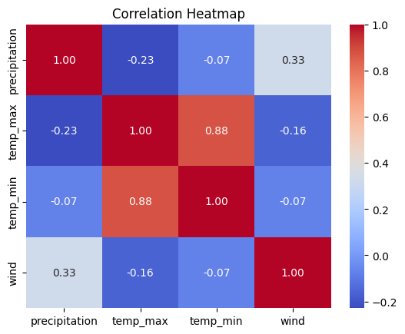

Figure 8. Heat map correlation

*Scatter Plot:*

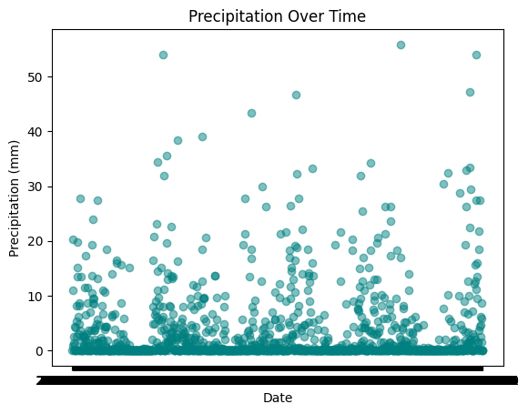

Figure 9. Scatter plot

*Pair Plot:*

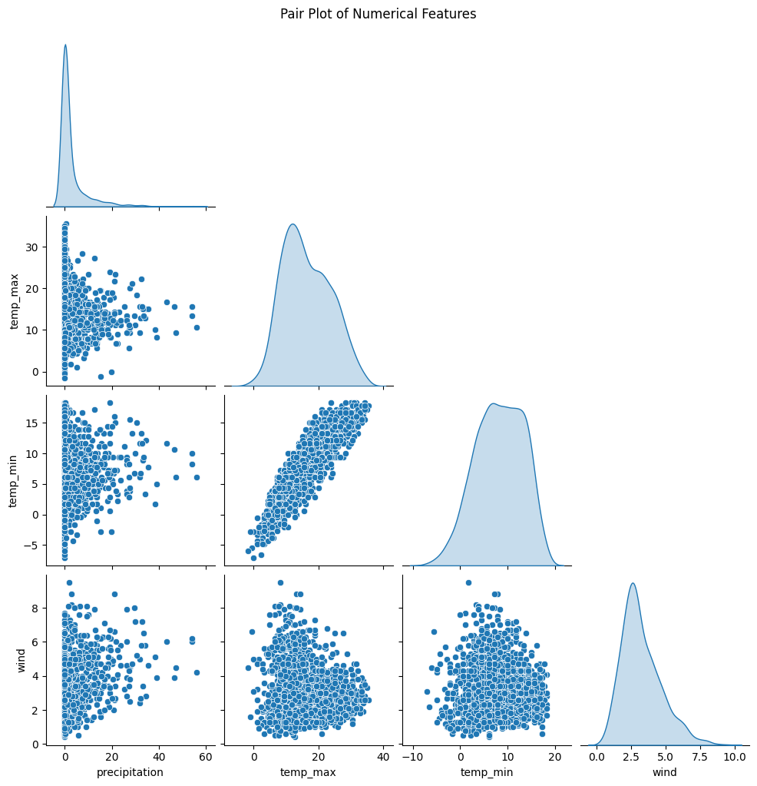

Figure 10. Pair plot

REFERENCES

[1] V. Suryanarayana, B. S. Sathish, A. Ranganayakulu, and P. Ganesan, “Novel Weather Data Analysis Using Hadoop and MapReduce - A Case Study,” *2019 5th International Conference on Advanced Computing and Communication Systems, ICACCS 2019*, pp. 204–207, Mar. 2019, doi: 10.1109/ICACCS.2019.8728444.

[2] V. B. Nikam and B. B. Meshram, “Modeling rainfall prediction using data mining method: A bayesian approach,” *Proceedings of International Conference on Computational Intelligence, Modelling and Simulation*, pp. 132–136, 2013, doi: 10.1109/CIMSIM.2013.29

[3] C. Kunjumon, S. S. Nair, S. Deepa Rajan, L. Padma Suresh, and S. L. Preetha, “Survey on Weather Forecasting Using Data Mining,” *Proc. IEEE Conference on Emerging Devices and Smart Systems, ICEDSS 2018*, pp. 262–264, Nov. 2018, doi: 10.1109/ICEDSS.2018.8544326

[4] A. Omary, A. Wedyan, A. Zghoul, A. Banihani, and I. Alsmadi, "An intelligent prescient framework for weather conditions determining," IEEE CITS 2012 - 2012 Worldwide Gathering on PC, Data and Telecom Frameworks, 2012, doi: 10.1109/CITS.2012.6220375.

[5] "Short-term load determining framework utilizing information mining | IEEE Meeting Distribution | IEEE Xplore." Got to: Nov. 30, 2024. [Online]. Accessible: https://ieeexplore.ieee.org/record/6084924https://ieeexplore.ieee.org/document/6084924

[6] I. A. B. Wan Abdul Razak, S. Container Majid, H. A. Rahman, and M. Y. Hassan, "Transient burden anticipating utilizing information mining method," PECon 2008 - 2008 IEEE second Global Power and Energy Meeting, pp. 139-142, 2008, doi: 10.1109/PECON.2008.4762460.

[7] Y. Canister Yang and H. Lin, "Spatio-fleeting information mining on MCS over tibetan level utilizing satellite meteorological datasets," Worldwide Geoscience and Remote Detecting Discussion (IGARSS), vol. 5, 2009, doi: 10.1109/IGARSS.2009.5417686.

[8] S. Ghosh et al., "Climate information mining utilizing fake brain organization," 2011 IEEE Late Advances in Wise Computational Frameworks,RAICS 2011, pp. 192-195, 2011,

doi: 10.1109/RAICS.2011.6069300.

[9] J. Q. Li, C. L. Niu, J. Z. Liu, and J. J. Gu, "The use of information mining in electric momentary burden determining," Procedures - fifth Worldwide Meeting on Fluffy Frameworks and Information Disclosure, FSKD 2008, vol. 2, pp. 519-522, 2008, doi: 10.1109/FSKD.2008.497.

[10] M. N. Wibisono and A. S. Ahmad, "Weather conditions determining utilizing Information Developing Framework (KGS)," Procedures - 2017 second Worldwide Meetings on Data Innovation, Data Frameworks and Electrical Designing, ICITISEE 2017, vol. 2018-January, pp. 35-38, Jul. 2017, doi: 10.1109/ICITISEE.2017.8285526.

[11] V. V. Anusuya and V. Gomathi, "Structure for cutting edge weather conditions determining procedure involving DMaaS in Cloud," Procedures of the 2018 Worldwide Gathering on Latest things towards Combining Advancements, ICCTCT 2018, Nov. 2018, doi: 10.1109/ICCTCT.2018.8550961.

[12] A. Mazhar, M. T. Ikram, N. A. Butt, and A. J. Butt, "Do we truly need to consider information digging methods for meteorological information," ICASE 2015 - fourth Global Meeting on Aviation Science and Designing, Jun. 2016, doi: 10.1109/ICASE.2015.7489525.

[13] M. A. I. Bin Saharudin, M. A. N. Bin Rosli, D. O. D. Handayani, A. B. B. Basri, Z. S. Attarbashi, and Z. Suryady, “Flood Forecasting Using Weather Parameters,” *2023 IEEE 9th International Conference on Computing, Engineering and Design, ICCED 2023*, 2023, doi: 10.1109/ICCED60214.2023.10425318.

[14] D. Ma, B. Sun, B. Jia, and Y. Li, “New energy short-term prediction system based on measured weather and network weather error correction,” *2019 3rd IEEE Conference on Energy Internet and Energy System Integration: Ubiquitous Energy Network Connecting Everything, EI2 2019*, pp. 1493–1498, Nov. 2019, doi: 10.1109/EI247390.2019.9061927.

[15] K. Xylogiannopoulos, P. Karampelas, and R. Alhajj, “Multivariate motif detection in local weather big data,” *Proceedings of the 2019 IEEE/ACM International Conference on Advances in Social Networks Analysis and Mining, ASONAM 2019*, pp. 749–756, Aug. 2019, doi: 10.1145/3341161.3343518.

[16] “ICT for automated forecasting of electrical power consumption: A case study in Maputo | IEEE Conference Publication | IEEE Xplore.” Accessed: Nov. 30, 2024. [Online]. Available: https://ieeexplore.ieee.org/document/6107372

[17] Y. Cui, “Intelligent Optimization Prediction and Application Based on Statistical Analysis and Data Mining,” *2023 3rd International Symposium on Computer Technology and Information Science, ISCTIS 2023*, pp. 465–469, 2023, doi: 10.1109/ISCTIS58954.2023.10213133.

[18] A. R. Finamore, V. Calderaro, V. Galdi, A. Piccolo, G. Conio, and S. Grasso, “A day-ahead wind speed forecasting using data-mining model-a feed-forward NN algorithm,” *2015 International Conference on Renewable Energy Research and Applications, ICRERA 2015*, pp. 1230–1235, 2015, doi: 10.1109/ICRERA.2015.7418604.

[19] “Project Triage; Methodology for profiling (behaviour / cause & effect) using a context matrix built though the integration of both characteristics and key performance indicators to create a profile sequence for a search structure within data mining and analytics | IEEE Conference Publication | IEEE Xplore.” Accessed: Nov. 30, 2024. [Online]. Available: https://ieeexplore.ieee.org/document/4699062

[20] A. Finamore, V. Calderaro, V. Galdi, A. Piccolo, and G. Conio, “A Day-ahead Wind Speed Prediction based on Meteorological Data and the Seasonality of Weather Fronts,” *2019 IEEE PES GTD Grand International Conference and Exposition Asia, GTD Asia 2019*, pp. 915–920, May 2019, doi: 10.1109/GTDASIA.2019.8715985.